Project Design Phase-II
Data Flow Diagram & User Stories

Date | 28 February 2026
Team ID | LTVIP2026TMIDS36731
Project Name | Heart Disease Analysis
Maximum Marks | 4 Marks

Data Flow Diagrams:
A Data Flow Diagram (DFD) is a traditional visual representation of the information flows within a system. A neat and clear DFD can depict the right amount of the system requirement graphically. It shows how data enters and leaves the system, what changes the information, and where data is stored.
Level 0
Example: (Simplified)
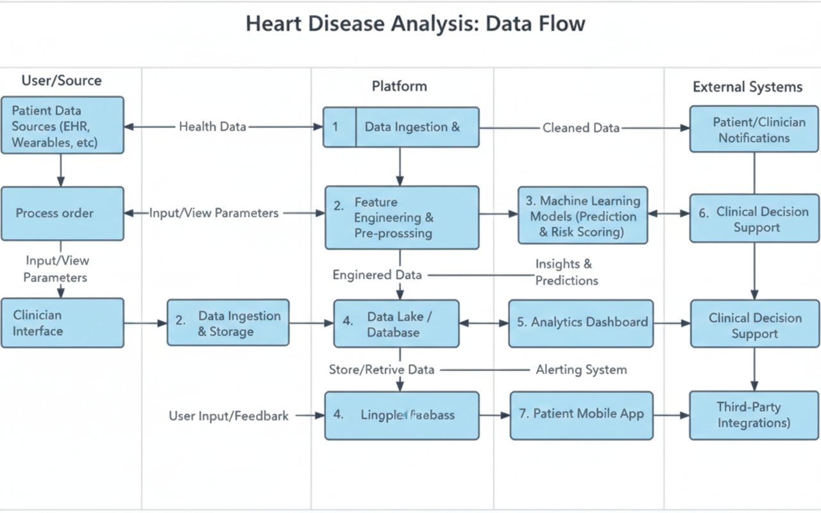
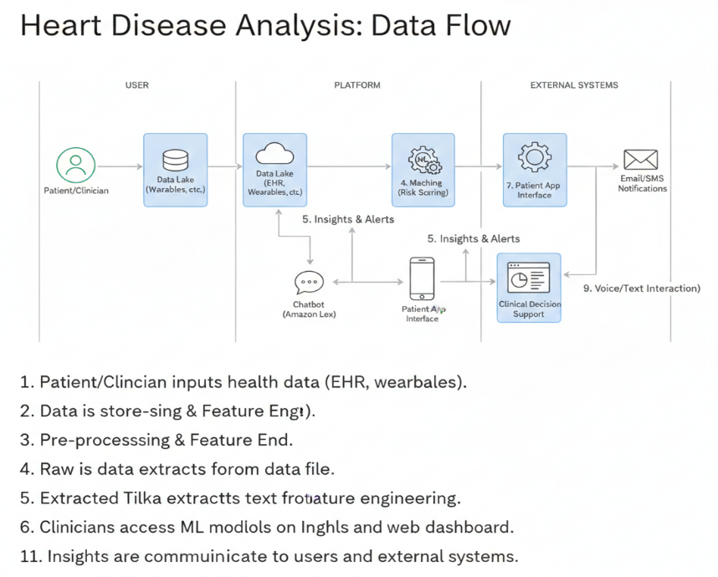

User Stories
Use the below template to list all the user stories for the product.
User Type | Functional Requirement (Epic) | User Story Number | User Story / Task | Acceptance Criteria | Priority | Release
Customer (Mobile user) | Registration | USN-1 | As a user, I can register for the application by entering my email, password, and confirming my password. | I can access my account / dashboard | High | Sprint-1
Customer (Mobile user) | Registration | USN-2 | As a user, I will receive confirmation email once I have registered for the application. | I can receive confirmation email & click confirm | High | Sprint-1
Customer (Mobile user) | Registration | USN-3 | As a user, I can register for the application through Facebook. | I can register & access dashboard using Facebook login | Low | Sprint-2
Customer (Mobile user) | Registration | USN-4 | As a user, I can register for the application through Gmail. | I can register & access dashboard using Gmail login | Medium | Sprint-1
Customer (Mobile user) | Login | USN-5 | As a user, I can log into the application by entering email & password. | I can successfully login and view dashboard | High | Sprint-1
Customer (Mobile user) | Dashboard | USN-6 | As a user, I can view heart disease prediction results on dashboard. | Prediction result is displayed clearly | High | Sprint-2
Customer (Mobile user) | Dashboard | USN-7 | As a user, I can upload health data for analysis. | Data upload is successful and validated | High | Sprint-2
Customer (Web user) | Dashboard | USN-8 | As a web user, I can view graphs and visualization of heart disease analysis. | Charts and graphs load properly | High | Sprint-2
Customer (Web user) | Reports | USN-9 | As a web user, I can download analysis reports. | Report downloads successfully in PDF/CSV | Medium | Sprint-3
Customer Care Executive | Support | USN-10 | As a support executive, I can assist users with login and data upload issues. | User issues can be tracked and resolved | Medium | Sprint-3
Customer Care Executive | Monitoring | USN-11 | As a support executive, I can view user activity logs. | User activity details are visible | Low | Sprint-3
Administrator | Model Management | USN-12 | As an admin, I can manage and update the prediction model. | Model updates successfully without errors | High | Sprint-4
Administrator | System Monitoring | USN-13 | As an admin, I can view system performance metrics. | Accuracy and model metrics are visible | High | Sprint-4
Administrator | User Management | USN-14 | As an admin, I can manage user accounts and permissions. | Admin can activate/deactivate users | Medium | Sprint-4

